Rapes Analysis in India
- Rape - Rape is the most heinous offence committed on a woman. It is worse than a murder. ... In India,it is defined as intentional and unlawful sexual intercourse with a woman without her consent.
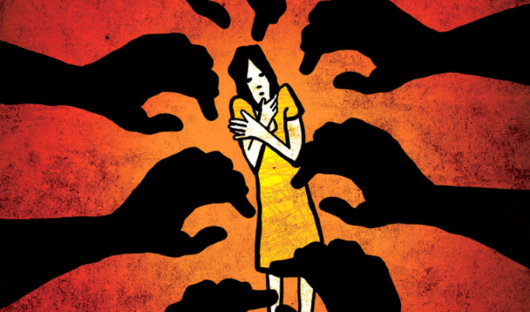
- Introduction -
Are effective steps being taken to ensure safety of women in our country? If yes, to how much extent are they successful and how much improvement is needed? Which regions are most unsafe and where the security needs to be tightened?..And many similar questions come across our minds when we think of women safety.
Diving into the data collected so far was the best option to get answers to these questions.
Data used in the analysis is extracted from the National Crime Records Bureau(NCRB) official website. Data which we analyzed , contains complete information about rapes crimes happened in India from 2001 to 2010. There are many factors that can be analyzed from the dataset. the dataset helps us to understand better about India. Rapes dataset contains 1050 rows × 11 columns.
- Data Analysis -
i) The rapes dataset contains 1050 rows and 11 columns . All columns of the dataset are mentioned below -
1. Area_Name
2. Year
3. Subgroup
4. Rape_Cases_Reported
5. Victims_Above_50_Yrs
6. Victims_Between_10-14_Yrs
7. Victims_Between_14-18_Yrs
8. Victims_Between_18-30_Yrs
9. Victims_Between_30-50_Yrs
10. Victims_of_Rape_Total
11. Victims_Upto_10_Yrs
ii) Column of subgroup is devided into three parts -
1. Total Rape Victims 350
2. Victims of Other Rape 350
3. Victims of Incest Rape 350
all parts of Subgroup have similiar value in the dataset which is 350.
iii) column of Area_Name has 34 unique values which are in form of states - ['Andaman & Nicobar Islands', 'Andhra Pradesh', 'Arunachal Pradesh' ......and So many.
iv) We creat new column of Unreported_rape_cases by differencing between Victims_of_Rape_Total and Rape_Cases_Reported.
v) In the rapes dataset our target variable is Victims_of_Rape_Total and this dataset contains two object type columns which are Subgroup and Area_Name and except of these all columns are numerical.
vi) Searching for missing values: blank spaces, words such as “NaN” or “null” and special characters such as “*” or “?” were searched for, as to verify if there were any missing values in the datasets. In this dataset there is no missing values .
- EDA -
figure -1 (as bar graph) - Area_Name vs Victims_of_Rape_Total
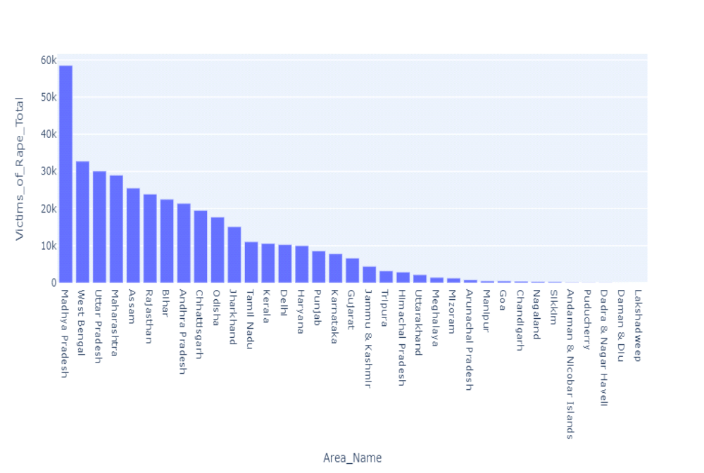
See the above graph, Madhya Pradesh reported a large number of cases since 2001, presently reaching a bar of more than 58000 cases. and second is Best Bengal in count of rapes cases. Orissa, Gujarat and Delhi standing in the midst with Daman & Diu, Pondicherry, Dadra & Nagar Haveli, Lakshadweep showing the minimum count. Though population density also plays a major role in predicting the most prone areas, but this stats shows the overall numbers.
figure -2 (as bar graph) - Year vs Victims_of_Rape_Total
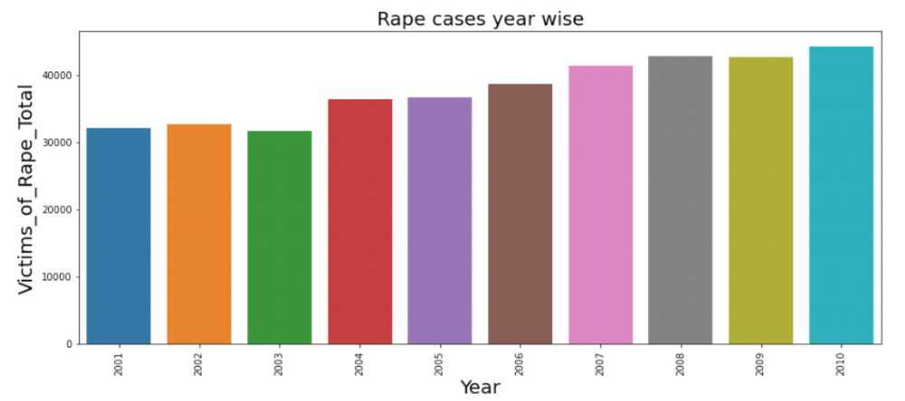
See the above graph, rape cases are increasing continuously since 2001 to 2010 but there is a little bit decreasement in rape cases in 2003. Above graph shows that India's women condition is not good because there is no strict law against the rape victims and may be people have no fear of the law ,they think they can escape from the law very easily. Now present need is sociaty should be aware and take care of the women with together.
figure-3(as line plot) - stats of all age groups of rape victims yearwise
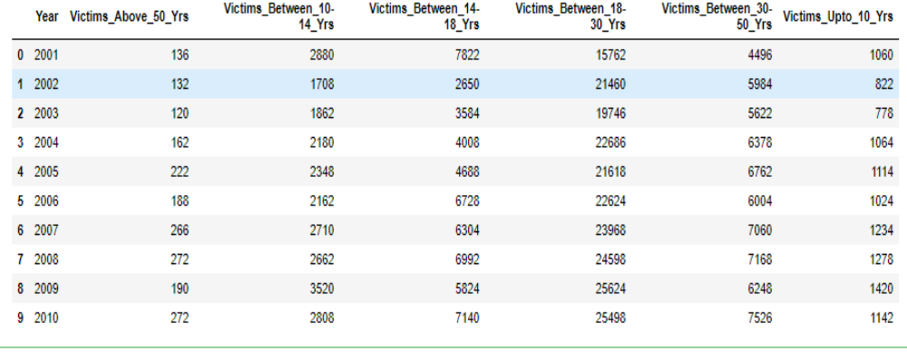
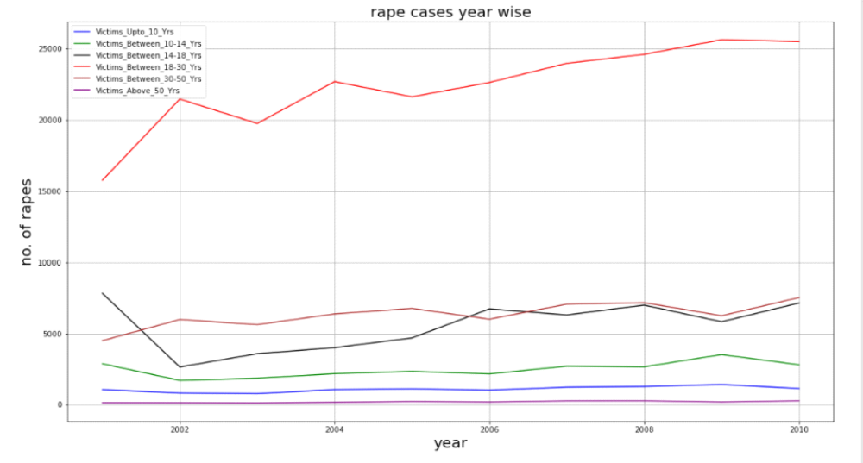
Above stats and graph shows that most of rapes are belongs to age group between 18 to 30. This age group rapes stats are increasing year wise continuously but there is decreasement in rape cases in 2003 and 2005. In this age group Above 25000 rape cases were recorded in year of 2009 and 2010.
Rape victims between age group 14 to 18, were recorded upto 8000. This age group victims decreased in 2002 but after that increasement was recorded.
Maximum Rape victims between age group 30 to 50 ,were recorded below 8000. There is slight decreasement and increasement in the rape cases year wise of this age group victims.
Other age group like upto 10 years, above 50 years and between 10-14 years also involved in violence against the women.
So people should be made aware by giving education about the women's contribution to built the nation. Concrete steps should be taken and solid laws should be made for the safety of women.
figure 4 (as line graph) - year wise rape cases reported and unreported
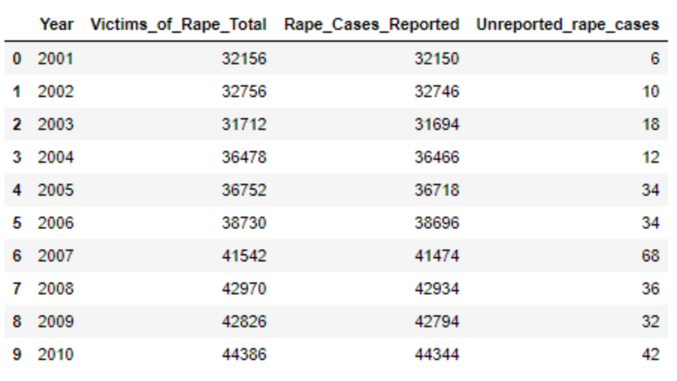
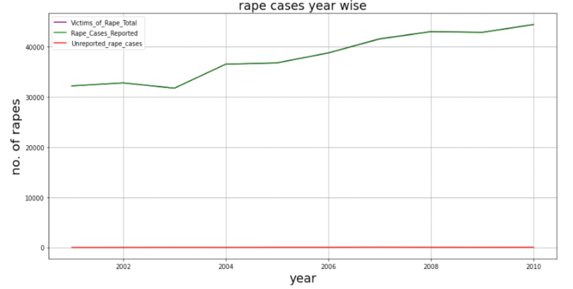
We can see that stats of Reported and Total rape cases are almost equal to each other and there is slightly difference between them which occurs as Unreported_rape_cases. Green line cover the purple line in line graph because of Reported and Total rape cases are almost equal to each other. Red line shows the Unreported rape cases. Maximum Reported and Total rape cases are recorded above 44000 in 2010. Maximum Unreported rape cases are recorded about 70 in 2007.
figure -5(as line graph) - Average of rape cases in every state
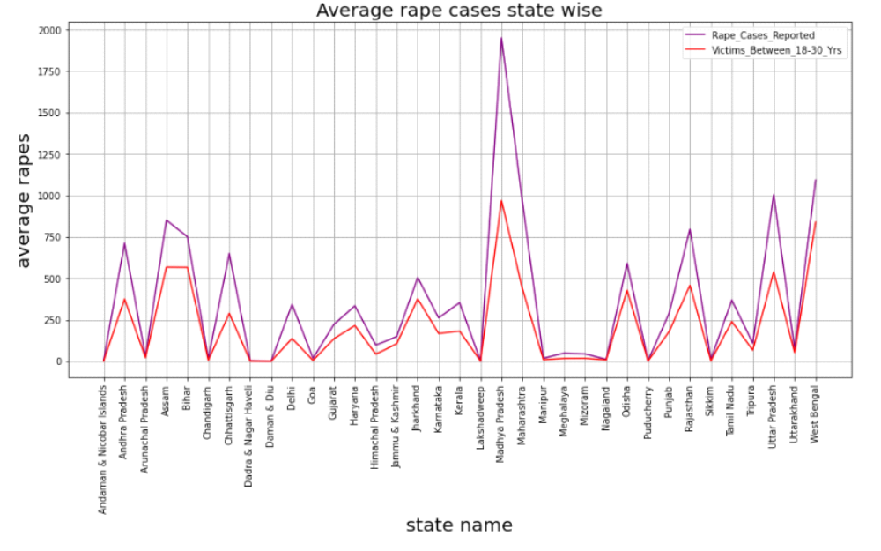
From the above graph it is clear that if we see average of rape cases then Madhya Pradesh is a state where Reported rape cases and Victims between 18-30 yrs, are high compare to other state. In the above stats West Bengal is on Second no. and Uttar Pradesh has no. 3. So we can say that mostly women are unsecure in Madhya Pradesh compare to other state according to above stats. Average rape cases reported in Madhya Pradesh between 1750 to 2000.
figure -6 (as bar graph) - Victims of total rape cases year wise in Madhya Pradesh
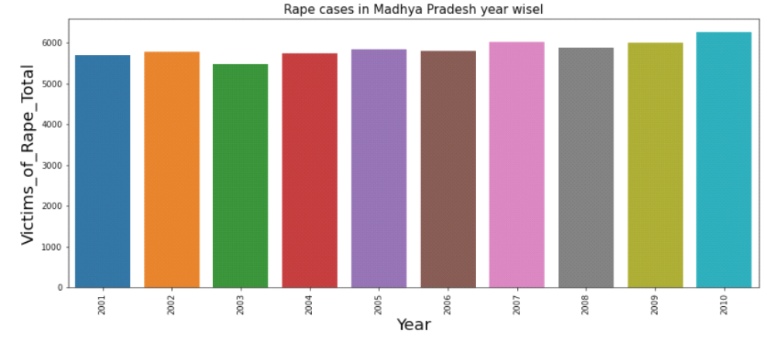
From above graph it is clear that decreasement is noticed since 2002 to 2006 after that in 2007 rape cases increased and broke the recordr of previous years. There is slightly decreasement in rape cases in 2008. In 2010 rape cases reached near 6000 and it was horrible because in this year rape cases are maximum compare to previous years.
figure -7 (as bar graph) - Victims of total rape cases year wise in West Bengal
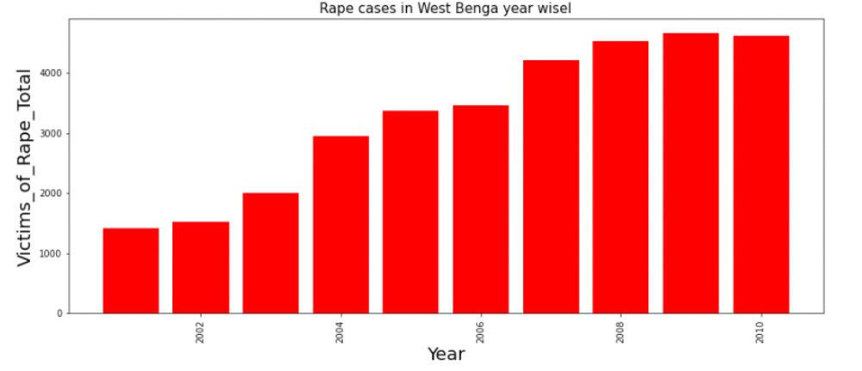
From above graph it is clear that victims of rape cases are increasing continuously year wise in West Bengal. In above graph no decreasement is noticed in rape cases in West Bengal, it means West Bengal's goverment is not looking at this side seriouly so that rape cases are increasing continuously. In 2001 total rape cases were 1400 and they reached about 4600 in 2009. There was little bit decreasement in 2010.
figure -8 (as bar graph) - Victims of total rape cases year wise in Uttar Pradesh
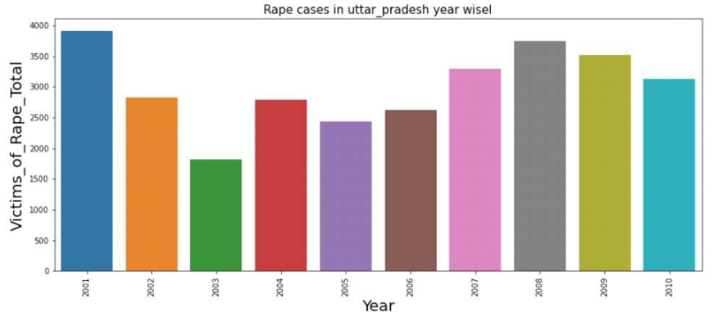
From above graph it is clear that total rape victims were maximum in 2001 in Uttar Pradesh after that stats of rape cases did not touch the maximum numbers of rapes in coming year till the end of 2010. Since 2002 to 2010, decreasement and incresement is noticed. So we can say that UP goverment is looking at this side seriously and taking concrete steps to stop the violence against the women.
- Conclusion -
Major takeaways are as follows:
The sharp growth or decline in number of cases given in the data does not really confirm about the present situation. There is a much need to encourage women speak against any sort to humiliation and to build their trust on the judicial system.
The states that experienced a rise in cases should have a screening to tackle the same.
Future trends of crime should be kept in mind for further amendments.
So now is the call for both the authorities and women themselves to come up with measures to control this rapid growing disease. Women have to take the responsibility to ensure their safety otherwise the above trend will keep on rising.
I also encourage others reading this post to research on their own level to counter the issue.
- Outliers detection - we apply some function or codes to detect the outliers. we see that our dataset is not normalized ,its mean outliers are present in our dataset so we should remove the outliers to getting appropriate dataset.
- removing columns - some columns should be remove to getting appropriate dataset to predict the best model. we remove columns of Area_Name and Subgroup because these columns are object type and label encoding is not good idea on these columns.
- removing outliers - In our dataset outliers are present so we remove the outliers by z-score method. After apply z-score method we lose data less than 5% so we would go with without outliers data.
- Model selection- firstly we create input split and after that we split the data in train_test_split.
1. LinearRegression model - we apply this model on our data and get the some results which are mentioned below -
MAE: 3.1983268039525176e-13
MSE: 2.5568007130061605e-25
RMSE: 5.056481694821174e-13
Accuracy= 100.0, Cross_val_score = 100.0
LinearRegression model is good because of Accuracy is 100 % but RMSE value is high so let's see other model.
2. RandomForestRegressor model - we apply this model on our data and get the some results which are mentioned below -
MAE: 1.4987136929460567
MSE: 20.060185477178347
RMSE: 4.478859841207173
Accuracy= 99.9847629244615, Cross_val_score = 99.88263182578052
RandomForestRegressor model Accuray is 99.98 which is good and it has less RMSE then the LinearRegression model so may be it might be a good model. Let's see another model.
3. SGDRegressor model - we apply this model on our data and get the some results which are mentioned below -
MAE: 0.13468521342080017
MSE: 0.05069582735297742
RMSE: 0.22515733910529637
Accuracy= 99.99996149307036, Cross_val_score = 99.9999041857454
SGDRegressor model Accuracy is 99.99 which is good think and it has law RMSE then the other model so we can say that this model is best for the predictions.
- Conclusions Remark
1. With the help of notebook I learnt how EDA can be carried out using Pandas and other plotting libraries.
2. Also I have seen making use of packages like matplotlib and seaborn to develop better insights about the data.
3. I have also seen how preproceesing helps in dealing with missing values and irregualities present in the data. I also learnt how to create new features which will in turn help us to better predict the survival.
4. I also make use of pandas profiling feature to generate an html report containing all the information of the various features present in the dataset.
5. I have seen the impact of columns like type, year/date on the Average price increase/decrease rate.
6. The most important inference drawn from all this analysis is, I get to know what are the features on which price is highly positively and negatively coorelated with.
7. I came to know through analysis which model will be work with better accuracy with the help of low residual and RMSE scores.
This project helped me to gain insights and how I should go with flow, which model to choose first and go step by step to attain results with good accuracy. Also get to know where to use Linear, RandomForestRegressor and other applicable and required models to fine tune the predictions.

